`ME-Mandaic incantation bowl

This magical incantation bowl, a yellowish colored, baked clay bowl. Its dimensions are 15 cm. in diameter at the opening and 5.6 cm. in depth. The text is divided into ten lines. The average diameter of a magical bowl at the lip is approximately 16 cm of upper diameter and it is usually 5-6 cm deep.Like other similar bowls, this bowl has its origin in southern Mesopotamia (south Iraq and the bordering area of Iran), and is dated to ca. the sixth century CE. These bowls are written in Judaeo-Aramaic, Syriac or Mandaic, the Aramaic dialects of that period. This bowl is written in Mandaic. The text is a popular incantation to save some persons that are tormented by harmful ghosts and spirits. The pattern or form of the spell and its elements are studied and compared with others similar magical texts inscribed in bowls like this one. A transcription of the Aramaic text is offered as well as its translation and a commentary.

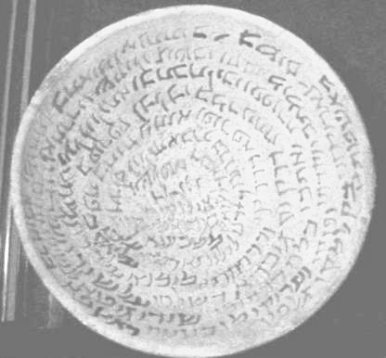

Though it is not clear the immediate origin of the piece, it does belong to the group of magic bowls from southern Iraq and the bordering area of Iran, dated to about the VI century. They were written in three Aramaic dialects, Jewish-Aramaic, Syriac and Mandaic.

The magical spells during this period in Mesopotamia were inscribed mainly on bowls made of fired clay. The spells were written with ink in the inner part of the bowls, sometimes also in the outside, usually creating spiral lines or just concentric circles in independent lines. The inscription may start in the central part of the concave side of the bowl, most frequently, or in the outer part. In some of the bowls, although very few, the inner area is divided into several parts, with text written in each of them.

Some bowls have been found in archaeological excavations and certain specific locations, such as the collection from Nippur4 or Khubair, located to the west of the present day Baghdad5. However, many of the bowls that we know nowadays have been sold by private individuals and, therefore, we are not sure about their exact origin, though all of them are originally from the southern Iraq and the bordering area of Iran

We find other incantations inscribed on bowls containing similar units which form the pattern of the spell. Although it appears to have been written in the dialect of the Mesopotamian Jews who were famous for formulations of magical incantations, the individual for whom this text was written was not necessarily Jewish. Similarly, T. Harviainen could not attribute Syriac incantations to Christians although they wrote in Syriac. Therefore, many incantation bowls have little trace of any particular religion.

References

Epstein, J.N.

1921 "Gloses babylo-arameenes", *REJ73,* pp. 27-58.

1922 "Gloses babylo-arameenes", *REJ74,* pp. 40-72.

Geller, M.J.,

1986 "Eight Incantation Bowls", *OLP71,* 101-117.

Gordon, Cyrus H.

1934a "An Aramaic Exorcism", *ArOr6,* 466-474.

1934b "An Aramaic Incantation", *AASOR* 14, 141-143.

Harviainen, T.

1995 "Pagan Incantations in Aramaic Magic Bowls", *Studia Aramaica* (JSS-Sup. 4),

pp. 53-60.

Isbell, Charles D.

1975 *Corpus of the Aramaic Incantation Bowls.* Scholars Press [Serie Dissertation

Series 17], Missoula, Montana.

Lidzbarski, Mark

1902 *Ephemeris fur semitische Epigraphik* I, Giessen.

Montgomery, James A.

1913 *Aramaic Incantations Texts from Nippur* (University of Pennsylvania, The

Museum, Publications of the Babylonian Section, vol. Philadelphia.  
Naveh, Joseph - Shaked, Shaul

1985 *Amulets and Magic Bowls: Aramaic Incantations of Late Antiquity,* Jerusalem‑

Leiden.

Naveh, Joseph - Shaked, Shaul

1993 *Magic spells and formulae: Aramaic incantations of late antiquity.* The Magnes

Press, The Hebrew University, Jerusalem

Pognon, Henry

1898-99 ***Inscriptions*** *mandaites des coupes de Kbouabir,* Paris [Reprinted: Amsterdam 1979].

Yamauchi, Edwin M.

1967 *Mandaic Incantation Texts* [American Oriental Series, 49] New Haven,

Connecticut.

E.M. Yamauchi, *Mandaic Incantation*

*Texts,* New Haven - Connecticut, 1967 (= Yamauchi 1967), pp. 1-67, regarding Mandaic bowls, J. Naveh - S. Shaked, *Amulets and Magic Bowls,* Leiden 1985 (= Naveh-Shaked 1985), pp.13-21, about Jewish-Aramaic bowls, V.P. Hamilton, *Syriac Incantations Bowls* (a Dissertation presented to the Brandeis University) 1971, pp. 1-35 and T. Harviainen, "Pagan Incantations in Aramaic Magic Bowls", *Journal of Semitic Studies - Suppplement 4,* 1995 (= Harviainen 1995), pp. 53-60 for Syriac bowls.